Recent I/O Problems
Question 4 (Final Spring 2016) I/O Coding in C

The built-in ADC on the PIC32 is only 10-bits and capable of 10⁶ samples per second (1 Msps) max, so an external ADC must be used for high-performance applications.

Consider a factory automation and control system with the following requirements:
- 16 different analog signals must be continuously sampled and converted
- Each analog input must be sampled at least 50000 times per second
- 16-bit resolution is needed for each sample
- Converted digital values must be stored into a memory array Buffer[16]. PIC32 writes to Buffer; a 2nd processor will read from Buffer and process the values.

16-bit ADCs are expensive, so you decide to use just one, assisted by a 16:1 analog MUX and a PIC32 microcontroller. The connection of these is shown in the circuit diagram.
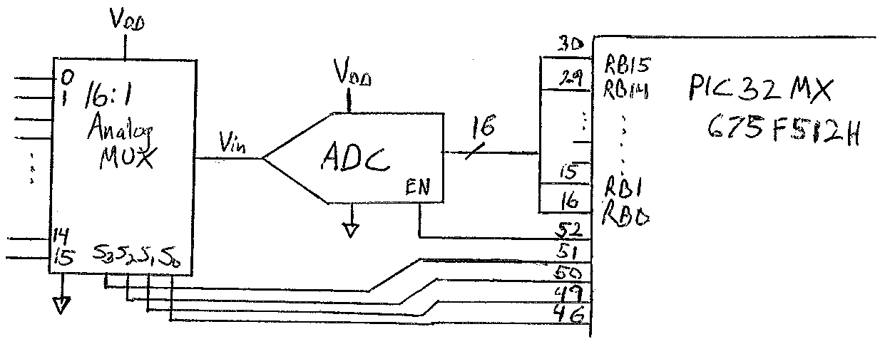

The 16-bit ADC you choose has the following characteristics:
- It samples the analog signal when EN is high
- It converts the analog sample to 16 digital bits when EN is low
- Minimum sample time is 500 nanoseconds
- Minimum conversion time is 750 nanoseconds
- The ADC input and output voltage levels are compatible with the PIC32’s 3.3 volt V_{DD}

To use the high-performance ADC at its maximum rate, you will need to write fast code that efficiently performs the tasks. You may use timers, but not interrupts. Assume that the system bus clock is running at 40 MHz and the peripheral bus clock is 20 MHz.

Your job is to write two C functions to meet the above requirements:
- the initialization routine void initQ4 (void) which runs once, setting up the ports and timers
- the ADC read routine void adcread (void) which runs continually. adcread must:
  - change the selection on the analog MUX to the next signal
  - sample the signal for at least 500 nsec
  - convert the sample for at least 750 nsec
  - take the converted 16-bit value from the ADC
  - store it in the next location in the Buffer
  - repeat

To take samples of 16 different signals at 50000 samples per second requires a sampling rate of 800 Ksps. 1/800000 means that each sample must be completed in 1250 nanoseconds, allowing just enough time for 500 nsec sampling and 750 nsec conversion. To accomplish this, the code must repeatedly hold EN high for exactly 500 nsec and low for exactly 750 nsec, with no wasted time in between. Highly efficient code must be designed, that has “tight” loops and very efficient processing of the signals.
- For efficiency, function calls and returns should be avoided. Therefore calls to delay_nsec(500) etc. are not used; instead, the code to wait 500 nsec (and the code to wait 750 nsec) must be “in-lined” into the adcread function.
- For efficiency, the wait times (500 nsec and 750 nsec) should be used to do useful work, instead of doing it outside the wait times, where it would add extra delay
- For efficiency, timers are not turned on and off, but left running
- For efficiency, the timer and the EN signal can be overlapped. Instead of the following code pattern, which leads to EN being high for too long,
EN = 1, Start_timer, … End_timer, EN =0
we should write overlapped code which gives the correct delay:
Start_timer, EN =1, … End_timer, EN =0

In the code below, it is assumed that there is a main function somewhere, as well as other functions which will read from Buffer[16] and use the values. It is also assumed that channel and Buffer[16] are declared as global/static variables, of type int, so that their scope will include initQ4 and adcread, and they will be valid in those functions.

Note: Since 16-bit conversion is needed, we cannot use the PIC’s own built-in 10-bit ADC. So any references its registers are incorrect, and are therefore not in the code below.

void initQ4 (void) {
TRISB = 0xFFFF; // all 16 bits are inputs for PORTB
TRISD = 0xFFE0; // lower 5 bits of PORD are outputs
PR1 = 10; // 10 clock cycles = 500 nsec (f_{peripheral_bus} = 50 nsec)
PR2 = 15; // 15 clock cycles = 750 nsec
T1CONbits.ON =1 // turn on Timer1 (and leave it running)
T2CONbits.ON = 1 // turn on Timer2 (and leave it running)
channel = 0; // initialize the global variable to channel 0
PORTD = channel; // set all PORTD output bits to 0: EN = 0, MUX select = 0
}

void adcread (void) {
while (1) {
// part A – sampling
TMR1 = 0; // start 500 nsec timer
PORTDbits.RD4 = 1; // EN = 1 to start sampling [Note: PORTD = 16 + channel
// will result in faster assembly code]
IFS0bits.T1IF = 0; // clear Timer1 interrupt flag bit
// as part of waiting, do preparatory tasks for part B here
Buffer[channel – 1] = PORTB; // get converted sample (ready from part B) and
// put it in the correct location in Buffer
while (! IFS0bits.T1IF) ; // until 500 nsec is done

// part B – conversion
TMR2 = 0; // start 750 nsec timer
PORTDbits.RD4 = 0; // EN = 0 to start conversion [Note: PORTD = channel
// will result in faster assembly code]
IFS0bits.T2IF = 0; // clear Timer2 interrupt flag bit
// as part of waiting, do preparatory tasks for part A here
channel = (channel + 1) % 16; // get ready for sampling next input (range is 0 to 15)
PORTD = channel; // set PORTD output bits to EN = 0, MUX select = next channel
while (! IFS0bits.T2IF) ; // until 750 nsec is done
} // end of while (1)
} // end of adcread

In order to meet the tight timing requirements of 1 sample per 1250 nanseconds (800 Ksps), the code must actually be tuned after compilation and assembly, to adjust the values of PR1 and PR2 slightly lower than 10 and 15. This is because of the software overhead, i.e. the instructions that are necessary to be done between the wait times and which cannot be done in parallel with waiting.

So even with the above code, which is designed for high efficiency, when it is converted into machine code, it will not be possible to meet the requirement of exactly 500 +750 = 1250 nsec per loop iteration. Assembly/machine instructions run at system bus clock rate (40 million per second, or 1 per 25 nanoseconds). So for each 2 “extra” MIPS assembly/machine instructions that are overhead outside the loop, 1 timer count should be eliminated from PR1 or PR2. Such tuning is typical in embedded system applications with tight timing constraints.

Question 4 (Fall 2015 Final) Receiving and outputting data in C code

a) Write the C function which will cause the PIC32 to receive 2500 8-bit values from a peripheral attached to SPI3. These input bytes are to be output onto PORTD. Under control of your function, the PIC32 should repeatedly read a value from the serial port and send it out on the parallel port, stopping when all 2500 values are transferred. For the SPI communication, let PIC32 be the master, and let transmission be at 2 MHz (assume the peripheral bus is clocked at 32 MHz).

#include <p32xxxx.h>

void Q4 (void) {
TRISD = 0xFF00; // set lower 8 bits of PORTD to output mode
SPI3CONbits.ON = 0; // turn off SPI3 port during configuration
SPI3BRG = 7; // f_{SPI3_clock} = 1/16 · f_{peripheral_clock}
SPI3CONbits.MSTEN = 1; // enable this SPI3 port to be master
SPI3CONbits.ON = 1; // turn on SPI3 port, it is ready to use

for (i = 0; i != 2500; i++) { // loop 2500 times
while (SPI3STATbits.SPIBUSY) ; // wait till input transmission is finished
PORTD = SPI3BUF; // move the value from SPI3BUF to PORTD
}

Question 4 (Fall 2015 Final) Low-level C-to-MIPS translation

b) Give the MIPS assembly program equivalent to the C code routine “delaymicros” (below, and on page 528 in the textbook). Tables from the PIC32 datasheet which may be useful are given.

#include <p32xxxx.h>

void delaymicros (int micros) {
if (micros > 1000) { // avoid timer overflow
delaymicros (1000) ;
delaymicros (micros – 1000) ;
}
else if (micros > 6) {
TMR1 = 0 ; // reset timer to zero
T1CONbits.ON = 1; // turn timer on
PR1 = (micros – 6) * 20 ; // 20 clocks/microsecond, 6 μs overhead
IFS0bits.T1IF = 0 ; // clear overflow flag
while ( ! IFS0bits.T1IF) ; // wait until overflow flag is set
}
}

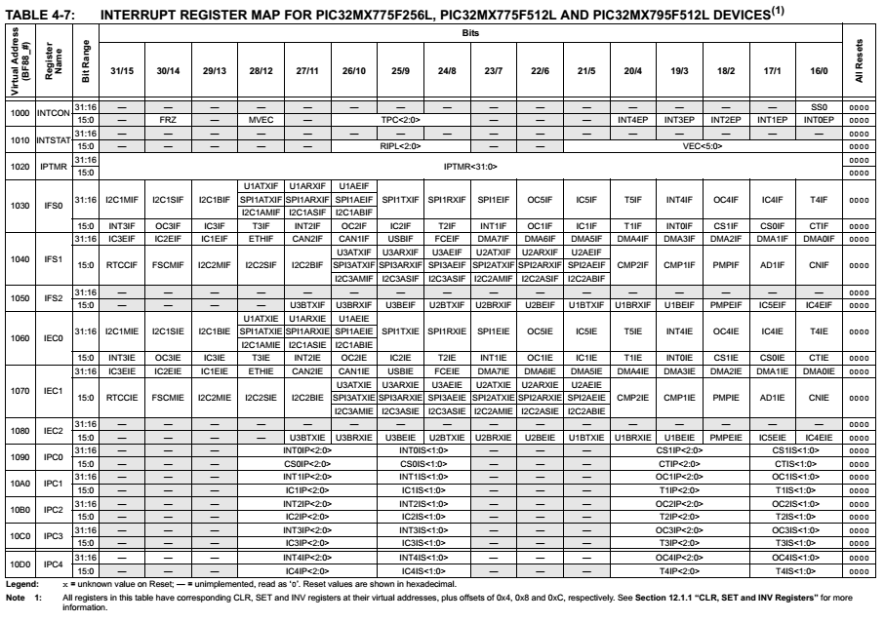

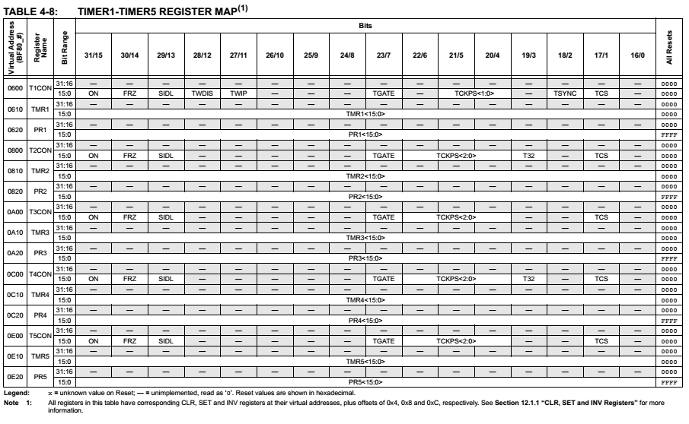

delaymicros:
addi $sp, $sp, -8 # push $a0 and $ra onto stack, to save
sw $a0, 4($sp) # $a0 is needed after the first jal call
sw $ra, 0($sp) # $ra will be changed by the jal calls

addi $t0, $0, 1000
ble $a0, $0, Else # test if (micros > 1000)

gt_1000: mov $a0, $t0 # put 1000 into $a0
jal delaymicros # call delaymicros(1000)
lw $a0, 4($sp) # put micros into $a0
addi $a0, $a0, -1000 # put micros-1000 into $a0
jal delaymicros # call delaymicros(micros-1000)
j Exit

Else: addi $t0, $0, 6
ble $a0, $t0, Exit # test if (micros > 6)

gt_6: lui $t1, 0xBF80 # address of TMR1 is BF800610
sw $0, 0x0610($t1) # TMR1 = 0

lw $t2, 0x0600($t1) # address of T1CON is BF800600
ori $t2, $t2, 0x8000 # set bit 15, the ON bit, to 1
sw $t2, 0x0600($t1) # T1CONbits.ON = 1

addi $a0, $a0, -6 # (micros – 6)
li $t2, 20
mult $a0, $a0, $t2 # (micros – 6) * 20
sw $a0, 0x0620($t1) # address of PR1 is BF800620

lui $t1, 0xBF88
lw $t2, 0x1030($t1) # address of IFSO is BF881030
li $a0, 0xFFFFFFEF # mask has all 1s, with a 0 in bit 4
and $t2, $t2, $a0 # clear bit 4, the T1IF bit, to 0
sw $t2, 0x1030($t1) # IFSObits.T1IF = 0

while: lw $t2, 0x1030($t1) # address of IFSO is BF881030
andi $t2, $t2, 0x0010 # mask has all 0s, with a 1 in bit 4
beq $t2, $0, while # if T1IF bit is 0, stay in loop

Exit: lw $ra, 0($sp) # restore original $ra value
addi $sp, $sp, 8 # restore $sp to original value
jr $ra # return to point of call

Question 1 (Quiz #6 Fall 2015) Give the MIPS assembly program equivalent to the C code below.
#include <p32xxxx.h>

char spi_send_receive (char send) {
SPI2BUF = send;
while (SPI2STATbits.SPIBUSY) ;
return SPI2BUF;
}

spi_send_receive: lui $t0, $0, 0xBF80 ## form 32-bit address of SPI2BUF in 2
## steps: 1st load upper 16 bits with lui
ori $t0, $t0, 0x5A20 ## ori completes the value 0xBF805A20
sw $a0, 0($t0) ## store send (in $a0) to SPI2BUF
Top: lw $t1, -16($t0) ## load in value from SPI2STAT
andi $t1, $t1, 0x0800 ## mask off all bits except SPIBUSY (= 11)
bne $t1, $0, Top ## if the value SPIBUSY is not 0, loop back
lw $v0, 0($t0) ## put SPI2BUF value into return register
jr $ra ## return to caller

Question 2 (Quiz #6 Fall 2015) Write the C function which will cause the PIC32 to transfer N 16-bit values from PortB to SPI4. N is the function’s input argument. PIC32 should repeatedly read a value from the parallel port and send it out on the serial port. For the SPI communication, let PIC32 be the master, let transmission be at 1 MHZ (based on f_{peripheral_clock} = 20 MHz).

#include <p32xxxx.h>
void Q4 (int N) {
int value;
TRISB = 0xFFFF; // set lower 16 bits of PORTD to input mode
SPI4CONbits.ON = 0; // turn off SPI4 port during configuration
SPI4BRG = 9; // f_{SPI4_clock} = 1/20 · f_{peripheral_clock}
SPI4CONbits.MSTEN = 1; // enable this SPI4 port to be master
SPI4CONbits.MODE16 = 1; // enable 16-bit mode, for 16-bit values
SPI4CONbits.ON = 1; // turn on SPI4 port, it is ready to use

for (i = 0; i != N; i++) { // loop N times
value = PORTB; // read in the value from PORTB
SPI4BUF = value; // output the value to SPI4 for transmission
while (SPI4STATbits.SPIBUSY); // wait till transmission is finished
}
}

Question #4 (Spring 2015 Final): Output control with feedback

You must use a PIC32 microcontroller to create an analog output voltage Vout. The characteristics of Vout are that it must be adjustable (e.g. is can change slowly, under program control) and it must be very accurate. However, low system cost is the other strong consideration, so no external DAC is affordable. You decide to use PWM as an inexpensive way to create the analog voltage, and to bring Vout back into the PIC32 as Vin (via the built-in ADC) for comparison and feedback control. In other words, if the measured Vin is too high, your program should reduce the duty cycle of the PWM signal to decrease Vout, and if it is too low, you will increase the duty cycle, to raise it. For various reasons, you decide to use 19.53125 KHz for the PWM signal frequency, and to generate it with OC5. The ADC will sample the value on AN5.

- Draw the circuit diagram of the system, including the PIC32 with all connections and pin numbers (and if needed, any external components) clearly shown.

OC5 is pin 52, for the output. AN5 is pin 11, for the input. The external RC filter (as shown in Figure 8.48) is needed, with a corner frequency ( f_{c} ) that is at least a factor of 10 lower than the PWM frequency. 19.53KHz/10 = 1.95 KHz, so a 1 K Ohm resistor with 0.1 x 10⁻⁶ Farad capacitor giving f_{c} = 1.59 KHz does the job.

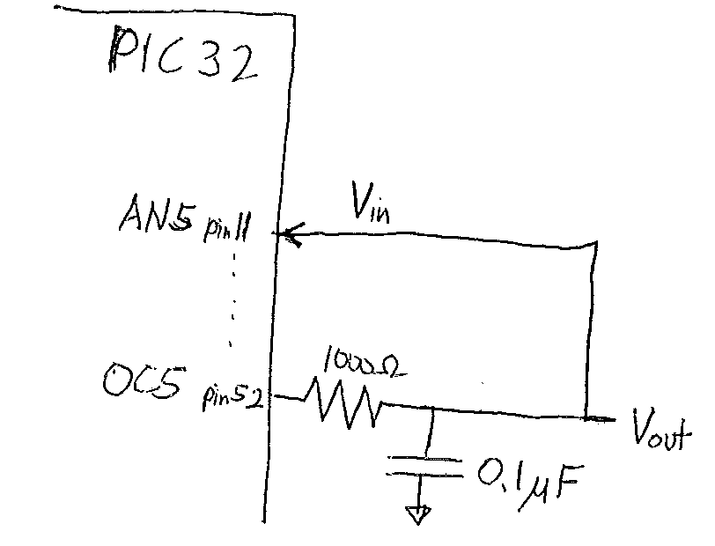

- What will be the period (in timer counts)? Why was this period chosen?

To generate a 19.53125 KHz PWM signal from the 20 MHz peripheral bus clock, the timer must have a period of (20 x 10^6)/(19.53125 x 10^3) = 1024. With a period of 1024 clock ticks, the duty cycle of the PWM signal can be modulated from 0 to 1023. Since the function input value desiredvalue is from 0-1023 and the 10-bit Vin input values coming from the ADC are also 0-1023, this choice of period makes for very easy and direct comparison of the values.

- Write code for the C function void outputVout (int desiredvalue) which takes a non-negative value between 0 and 1023 that is proportional to the desired Vout voltage, and accomplishes the task described above and here. [Note: Rather than receive a real number between 0 and 3.3, it is easier to use integer parameters. Thus it is expected that the calling program does the conversion from (0--3.3) to (0—1023), and gives this number as the desiredvalue. ]

Good software practice uses modularity, so here too it is expected that you will break up your program into pieces, such as initializing the I/O devices, outputting the desired PWM signal, inputting the analog signal and converting it to its digital equivalent, comparing the average Vin to the desired Vout, and adjusting as necessary, and of course doing this repeatedly so as to maintain tight accuracy on Vout. For each such function, you should either use existing C functions from the book if they can be directly used, modify such functions so that they can be used, or write your own new function.

The overall structure of the outputVout function begins with initialization of the ADC (notice that void initadc (int channel) on page 533 works great as is!) and assignment of the desiredvalue to be the initial dutycycle. However, the PWM doesn’t need any initialization other than what is already in void genpwm (int dutycycle) on page 537.

An unending while loop is needed to repeatedly generate the PWM signal with the current duty cycle, then read the ADC, and then compare that new value against the desired value, to see if the duty cycle needs to increase or decrease.

It is necessary to modify genpwm to make it have a period of 1024, and to make it use OC5. But it can still work with Timer2, in 16-bit mode, which is the default. Call the new function genpwmQ4.

#include <p32xxxx.h>

void genpwmQ4 (int dutycycle) { // very similar to genpwm in book on p. 537
PR2 = 1023; // set period to 1023+1 ticks => 19.53125 KHz
OC5RS = dutycycle; // set duty cycle of PWM signal
OC5CONbits.OCM = 0b110; // set OC5 module to PWM mode
T2CONbits.ON = 1; // turn on Timer2 in default mode: 20 MHZ,
// 16 bit counter
OC5CONbits.ON = 1; // turn on OC5 module
}
void outputVout (int desiredvalue) {
int dutycycle;
int newval;

initadc (5); // AN5 is on pin 11
dutycycle = desired value; / /set initial dutycycle
while(1) {
genpwmQ4 (dutycycle); // output the Vout voltage using PWM
newval = readadc( ); // read ADC and convert Vin to newval
if (newval < desiredvalue) dutycycle++;
else if (newval > desiredvalue) dutycycle--;
}
}

Question #1 (Spring 2015 Final): Low-level C-to-MIPS translation
c) Translate the following C code into MIPS assembly code, as the PIC32 compiler would based on the p32xxxx header file. You can refer to the Table 4-16 from the PIC32 datasheet. Use only real MIPS instructions.

int readadc (void) {
AD1CON1bits.SAMP = 0 ;
while (!AD1CON1bits.DONE) ;
AD1CON1bits.SAMP = 1 ;
AD1CON1bits.DONE = 0 ;
return (ADC1BUF0) ;
}

readadc: lui $t0, 0xBF80 // load AD1CON1 address into $t0
ori $t0, $t0, 0x9000 // (0xBF809000 from Table 4-16)
lw $t1, 0 ($t0) // get AD1CON1 value into register $t1
andi $t1, $t1, 0xFFFD // AND mask to clear bit 1 (SAMP bit)
sw $t1, 0 ($t0) // store value back to AD1CON1
while: lw $t1, 0 ($t0) // get AD1CON1 value into register $t1
andi $t2, $t1, 0x0001 // AND mask to clear all bits except bit 0
// (DONE bit)
beq $t2, $0, while // spin in while loop until DONE = 1
ori $t1, $t1, 0x0002 // OR mask to set bit 1 (SAMP bit)
andi $t1, $t1, 0xFFFE // AND mask to clear bit 0 (DONE bit)
sw $t1, 0 ($t0) // store value back to AD1CON1
lw $v0, 0x70 ($t0) // load ADC1BUF0 into $v0
// (address is 0xBF809070 in Table 4-16)
jr $ra // return to callee

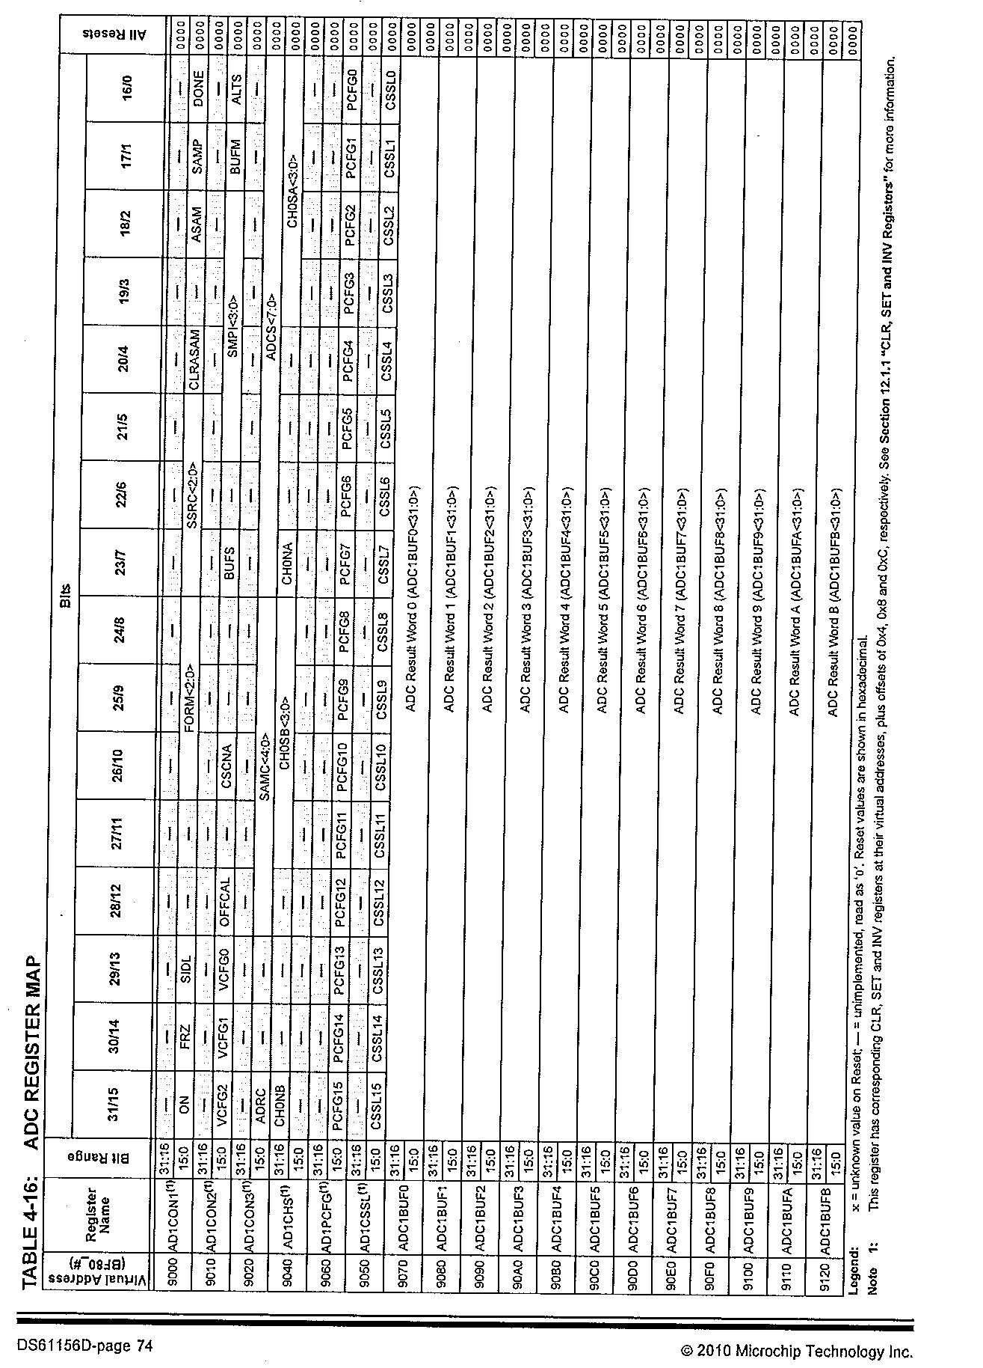
Question #1 (Spring 2015 Retake): Low-level C-to-MIPS translation
b) Translate the following C code into MIPS assembly code, as the PIC32 compiler would based on the p32xxxx header file. You can refer to the Table 4.14 from the PIC32 datasheet.

char spi_Q1 (char send) {
SPI2CONbits.ON = 0;
SPI2BRG = 7;
SPI2CONbits.MSTEN = 1;
SPI2BUF = send ;
while (SPI2STATbits.SPIBUSY) ;
return (SPI2BUF) ;
}

The values given in Table 4.14 show the addresses of the 4 special function registers (SFRs) used in this program: SPI2CON = 0xBF805A00, SPI2STAT = 0xBF805A10,
SPI2BUF = 0xBF805A20, SPI2BRG = 0xBF805A30. Additionally it shows that in SPI2CON, the ON bit is 16, and MSTEN is bit 5. In SPI2STAT, bit 11 is SPIBUSY.

Spi_Q1: lui $t0, 0xBF80 //load upper half of all SPI2 addresses
// SPI2CONbits.ON = 0
lw $t1, 0x5A00($t0) // t1 ← value of SPI2CON
lui $t2, 0xFFFF // t2 ← FFFF0000
ori $t2, $t2, 0x7FFF // t2← FFFF7FFF (only bit15 is 0)
and $t1, $t1, $t2 // t1 ← t1 with bit 15 cleared to 0
sw $t1, 0x5A00($t0) // VM[SPI2CON] ← modified t1 value
// SPI2BRG = 7
addi $t1, $0, 7 // temp ←7
sw $t1, 0x5A30 // VM[SPI2BRG] ← temp (=7)
// SPI2CONbits.MSTEN = 1
lw $t1, 0x5A00($t0) // t1 ← value of SPI2CON
ori $t1, $t1, 0x0020 // OR mask bit5 is 1, sets MSTEN bit
sw $ t1, 0x5A00($t0) // VM[SPI2CON] ←modified t1 value
// SPI2BUF = send
sw $a0, 0x5A20($t0) // VM[SPI2BUF] ← a0 (input argument)
// while (SPI2STATbits.SPIBUSY) ;
while: lw $t1, 0x5A10($t0) // t1 ← VM[SPI2STAT}
andi $t1, $t1, 0x0800 // AND mask bit16 is 1, clears all others
bne $t1, $0, while // repeat while bit16 (SPIBUSY) = 1
// return (SPI2BUF)
lw $v0, 0x5A20($t0) // v0 ← VM[SPI2BUF]
jr $ra // return to callee

Note: 2 assembly language instructions could be saved by reordering the C code to

SPI2CONbits.ON = 0;
SPI2CONbits.MSTEN = 1;
SPI2BRG = 7;
SPI2BUF = send ;
and just doing the loading from SPI2CON ( = 0xBF805A00), and storing to it, only once. An optimizing compiler would do this reordering to gain the speedup.
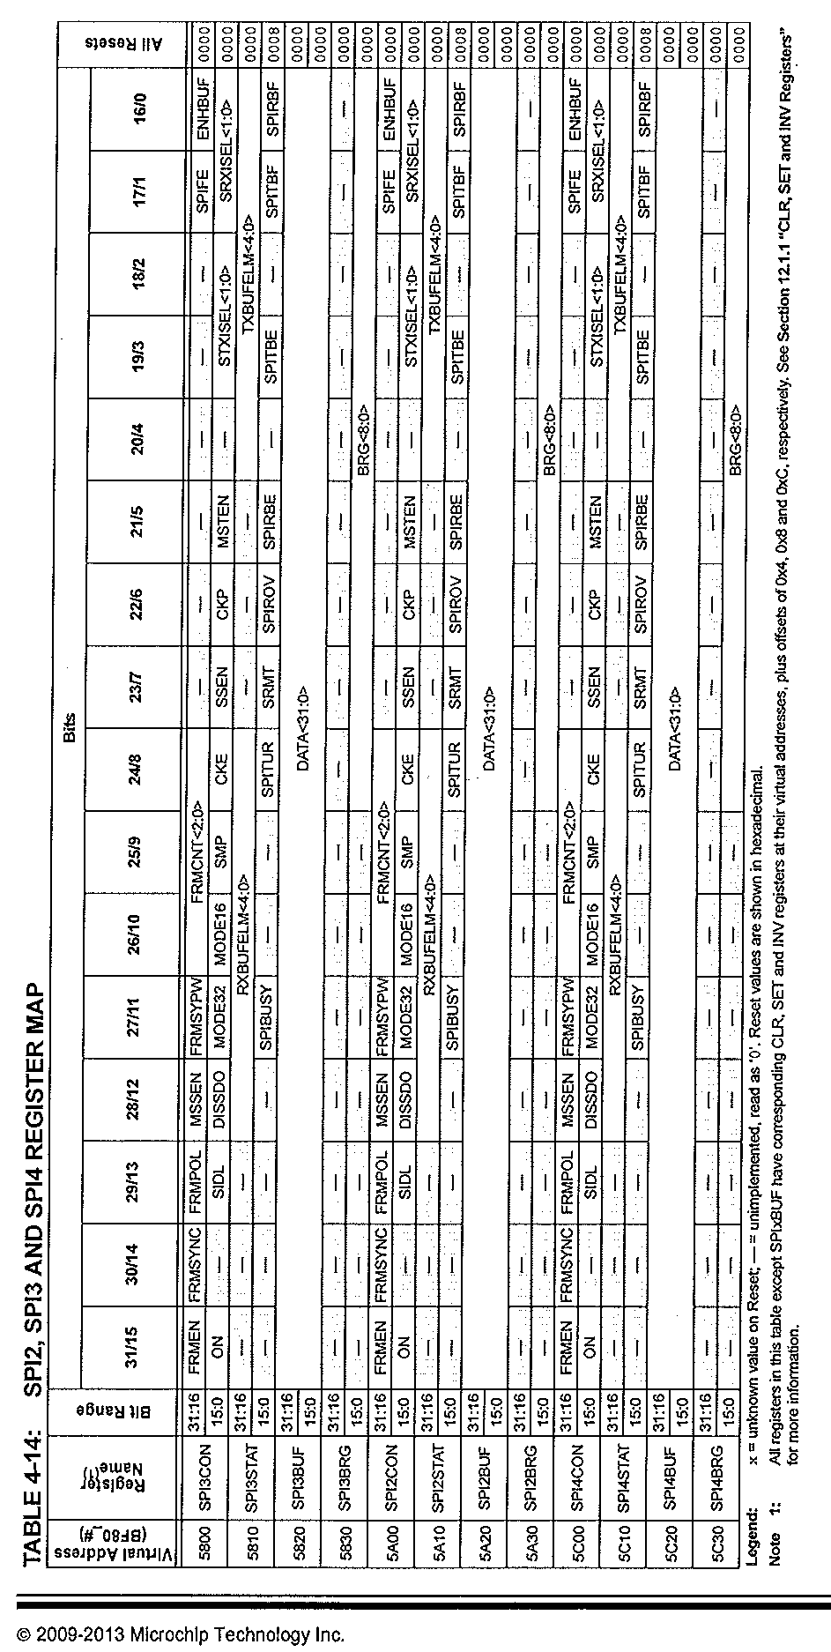
Question #5 (Spring 2014 Final Exam): Writing C code for I/O control

Write C codes for the following 3 functions, for an embedded PIC32 microcontroller. You may assume the PIC32MX675F512H is the target device.

a) char get_ADC (void) will initialize and read the built-in ADC 10-bit value (sampled and converted from pin 14 on the chip) and convert it into an 8-bit value, limit it to the range 0-100, and return this value.

Solution:
// Pin 14 is AN2. The most significant 8-bits from the 10-bit ADC sample must be taken
char get_ADC (void) {
char value
AD1CSHbits.CHOSA = 2; // select channel 2, since pin 14 = AN2
AD1PCFGCLR = 1 << 2; // clear bit 2, to allow analog input
AD1CONbits.ON = 1; // turn on the ADC
AD1CONbits.SMP = 1; // begin sampling the analog signal
AD1CONbits.DONE = 0; // clear the DONE flag
// depending on clock rates, may need to wait more
// cycles for sampling to complete
AD1CONbits.SMP = 0; // end sampling, start the conversion
while (!AD1CONbits.DONE); // spin and wait for conversion till DONE goes high
value = ADC1BUF0 >> 2; // take most significant 8 bits of result
if (value > 100) value = 100; // upper limit is 100
return value;
}

b) char get_PIO (void) will initialize and read in the parallel 8-bit value on pins 3-1, 64-60 on the chip, limit it to the range 0-100, and return this value.

Solution:
// Pins 3-1,64-60 are RE7-RE0

char get_PIO (void) {
char value;
TRISE = 0x00FF; // set lower 8 bits of PORTE to input, for pins 3-1,64-60
value = PORTE; // get 8-bit value
if (value > 100) value = 100; // upper limit is 100
return value;
}

c) void give_PWM (int dutycycle) takes one input parameter (the percentage dutycycle, in the range from 0% to 100%). It initializes the OC module and associated timer, then causes the PWM signal with this dutycycle to be output on pin 52.

Solution:
// Pin 52 is OC5; RS holds the # of counts in the PWM duty cycle
// PR2 holds the (# of counts -1) in the full cycle

void give_PWM (int dutycycle) {
PR2 = 99; // Period of Timer2 is 99+1 = 100 clock pulses
// Output on OC5, which is pin 52
OC5RS = dutycycle; // OC5RS register controls the duty cycle for OC5
OC5CONbits.OCM = 0b110; // set OC5 to PWM mode, using Timer2 in 16-bit mode
T2CONbits.ON = 1; // turn on Timer2
OC5CONbits.ON = 1; // turn on OC5, to start PWM signal output
}

Question #1 (Spring 2014 Final): Low-level C-to-MIPS translation

The 2 short C routines below must be hand-compiled into MIPS assembly code. The memory mapped I/O registers are located at the following locations:
SPI1BUF = 0xFFFFF000, SPI1STAT = 0xFFFFF004 (with SPIBUSY being bit4),
TRISB = 0xFFCC0000, PORTB = 0xFFCC0004 . Your code should follow the MIPS convention for register usage and function calls. You may use pseudo-instructions.

a) char routine1(char inbyte) {
SPI1BUF = inbyte;
while (SPI1STATbits.SPIBUSY);
return SPI1BUF;
}

Solution: [Remember: in load and store instructions, sign extension turns 0xF000 into 0xFFFFF000. In logical instructions, zero-extension is used.]

routine1: sw $a0, 0xF000 ($0) # SPI1BUF gets inbyte (input argument)
While1: lw $t0, 0xF004 ($0) # get SPI1STAT value
andi $t0, $t0, 0b00010000 # AND with mask to get bit4 value only
bne $t0, $0, While1 # if SPIBUSY, spin in while loop, until
# new SPI1BUF value is ready
lw $v0, 0xF000 ($0) # put SPI1BUF value into return register
jr $ra # return to callee

b) void routine2(void) {
int temp;
TRISB = 0x000F;
while (PORTB & 0xF != 0x0) {
temp = PORTB;
PORTB = temp << 4;
}
}

Solution: [Remember: in load and store instructions, sign extension turns 0xF000 into 0xFFFFF000. In logical instructions, zero-extension is used.]

routine2: lui $t0, 0xFFCC # put TRISB address into $t0
li $t1, 0xF # put port mask into $t1
sw $t1, 0($t0) # write port mask to TRISB
While2: lw $t1, 4($t0) # read PORTB into $t1
andi $t2, $t1, 0xF # and PORTB value with 0xF
beq $t2, $zero, End # leave loop if equal to 0
# no temp needed, PORTB value is in t1
sll $t2, $t1, 4 # shift t1 value left 4 places
sw $t2, 4($t0) # write shifted value to PORTB
j While2 # [Note: a bottom-tested loop would use bne
# here, not need this jump or beq above]
End: jr $ra # return to callee

Question #1 (Spring 2014 Retake): Low-level C-to-MIPS translation
b) For this part, PORTD = 0xFFFF0000 and TRISD = 0xFFFF0004. Other conditions are the same as in part a).

int problem_1b (int a) {
TRISD = 0xFF00;
PORTD = a;
while (PORTD & 0xFF00 == 0) ;
return PORTD;
}

Answer
b) (8 points)
problem_1b: addi $t0, $0, 0xFF00 # put 0xFF00 into $t0
lui $t1, 0xFFFF # PORTD address = 0xFFFF0000, put into $t1
sw $t0, 4($t1) # TRISD address (=FFFF0004) gets 0xFF00
sw $a0, 0($t1) # PORTD gets $a0, which contains a
spin: lw $t2, 0($t1) # get PORTD value
and $t3, $t2, $t0 # PORTD & 0xFF00
beq $t3, $0, spin # spin while PORTD & 0xFF00 = 0
addi $v0, $t2, 0 # put PORTD value into $v0 for return value
jr $ra # return to point of call

Quiz #6 (Spring 2015) Low-level C-to-MIPS translation

Give the MIPS assembly program equivalent to the C code in Example 8.18
#include <p32xxxx.h>

int main(void) { main:
int switches; li $t0, 0xFF00
li $t1,0xBF8860C0
TRISD = 0xFF00; sw $t0, 0($t1)
while (1) { while1: bne $0,$0, end
switches = (PORTD >> 8) & 0xF; li $t1,0xBF8860D0
lw $t0, 0($t1)
srl $t0, $t0, 8
andi $t0, $t0, 0xF
PORTD = switches; sw $t0, 0($t1)
} j while1
} end:

Quiz #7 (Spring 2015 Section 1): Using PIC and PWM to create a 5 Hz triangle wave

Using a PIC32 microcontroller, plus a 1000 Ohm resistor and a 100 milliFarad capacitor, design a system that produces a 5 cycles/second triangle waveform with peak amplitude 3.3 Volts and minimum of 0V, using the PWM technique. Let the waveform have 64 points per period.

a) Give the circuit diagram, showing the connection of the hardware.

The connection is the same as the one given in Figure 8.48 on p. 537. By using pin 46 for OC1, much code can be reused.
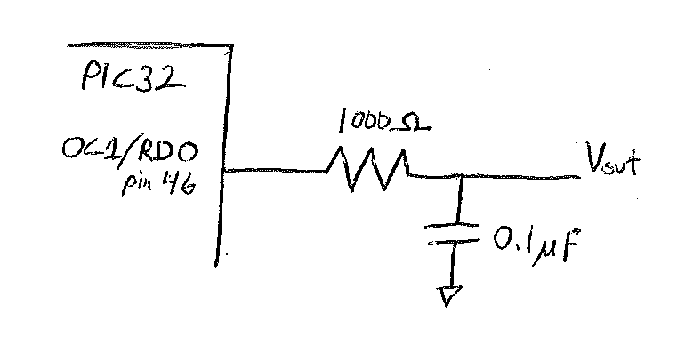

b) Give the C code for the microcontroller. To save time and reduce errors, you can call any functions that are already written, such a delaymicros, initwavetables, etc. But be sure that your new code is compatible with the pre-existing functions you call.

#include <p32xxxx.h>
#include <math.h>
#define NUMPTS 64

int triangle[NUMPTS], sine[NUMPTS];

void gentriwave(void) {
int i;
while (1) {
for (i=0; i<NUMPTS; i++) {
genpwm(triangle[i]); //output next value using PWM
delaymicros(3125); //wait 3.125 milliseconds
}
}
}

int main (void) {
initwavetables( );
gentriwave( );
}
Notes about the solution code:
--in order to use initvavetables ( ), the math.h header file must be included, and sine[NUMPTS] must be declared globally
--since genpwm function expects a duty cycle from 0 to 255, it is directly compatible with the values in triangle[NUMPTS] created by initwavetables.
--since the RC low-pass filter has cutoff frequency of 1.6 KHz, the 78.125 KHz PWM carrier signal will be filtered out, but the 5 HZ triangle wave will pass through unattenuate to Vout
--the triangle wave has period T = 1/5 = 0.2 sec = 200 milliseconds, so the time between points is (200 x 10^-3 sec/period)/(64 points/period) = 3.125 x 10^-3 = 3125 x 10^-6 seconds/point

Quiz #7 (Spring 2015 Section 2): LED control using ADC and signal classification

Using a PIC32 microcontroller, design a system to sample an analog signal on pin 22, which will have a maximum amplitude of 3.3 Volts and minimum of 0V. If the value is greater than 3V, light up 3 LEDs, if it is between 2-3 volts, light up 2 LEDs, if 1-2 volts, light up 1 LED. Assume that the LEDs are connected to port D as shown in Figure 8.35

a) For the PIC32 built-in A-to-D converter, give the digital equivalent outputs for the following analog inputs:
Vin | X (digital bit values)
0V |
1V |
2V |
3V |
3.3V |

The PIC32 built-in ADC is 10-bits (N=10), and is powered by 3.3V (=Vref+) and 0V (=Vref-). So Equation 8.5 on p. 531 becomes X = 2^10(Vin/3.3). So for Vin= 0, 1, 2, 3 and 3.3, the respective X values (in base 10, rounded to the nearest integer) are 0, 310, 621, 931 and 1024. So the table is:

Vin | X (digital bit values)
0V | 00000 00000 (=0)
1V | 01001 10110 (= 310)
2V | 10011 01101 (= 621)
3V | 11101 00011 (= 931)
3.3V | 11111 11111 (=1023, the max for 10 bits)

b) Give the C code for the microcontroller which will accomplish the above task continuously. . To save time and reduce errors, you can call any functions that are already written. But be sure that your new code is compatible with the pre-existing functions you call.

Pin 22 on our PIC32 is for AN9, so Analog channel 9 must be selected for the ADC. The initadc and readadc functions on page 533 are totally compatible with the code below, and therefore can be used without any modification.

#include <p32xxxx.h>

void writeLEDs (int value) {
if (value>931)
PORTD = 7; //Vin > 3V, so light 3 LEDs
else if (value≥621)
PORTD = 3; //Vin ≥ 2V, so light 2 LEDs
else if (value≥310)
PORTD = 1; // Vin ≥ 1V, so light 1 LED
else PORTD = 0; // Vin < 1V, so light 0 LEDs
}
int main (void) {
int value;
TRISD = 0xFF00; // set RD[7:0] to output, as in Figure 8.35
initadc(9); // initialize & setup ADC, using pin 22 for AN9
while(1) {
value = readadc( ); // get new value from ADC
writeLEDs(value); // convert it to LED outputs
}
}

